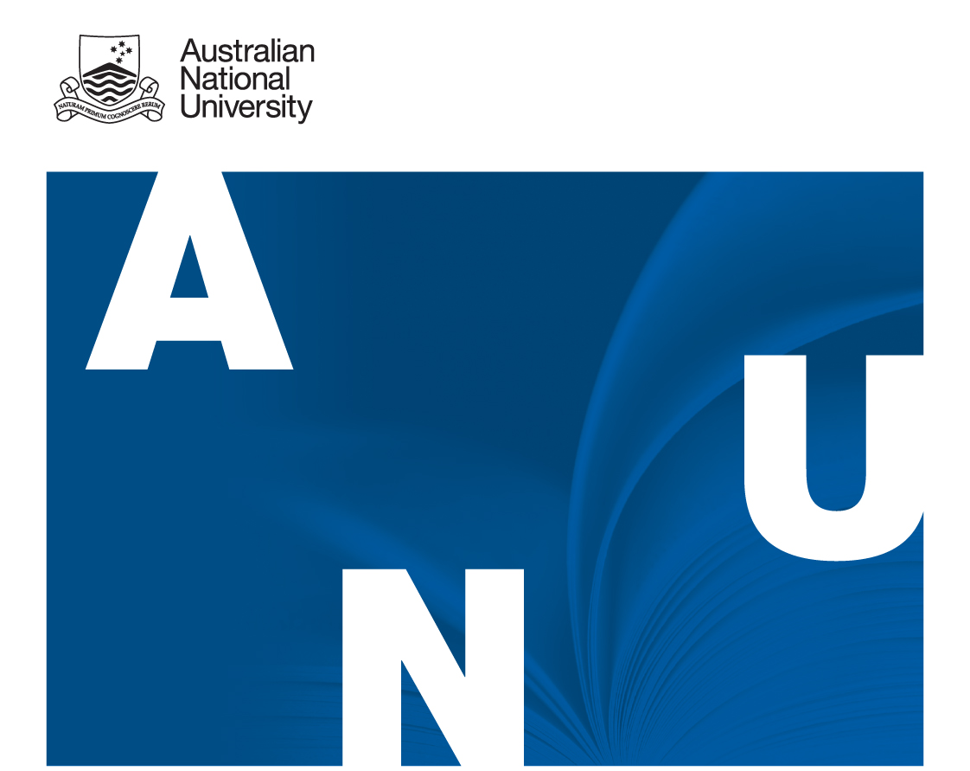

2012 Review of administration– School of language studies, rsha, cass
information & Terms of reference

Background

The School of Language Studies was originally established as part of the former Faculty of Arts. In January 2010, it was transferred into the Research School of Humanities & the Arts, as part of the structural re-organisation of the ANU College of Arts & Social Sciences to integrate disciplines into single academic organisational units. In 2011 the administration of the School was re-organised consistent with the framework set out in the CASS Workforce & Capability Plan (Administration).

It is timely to consider and review the current administrative arrangements of the School as it has been operating for over two and half years (under the integrated structure) with the current administrative staffing structure in place for over a year.

The purpose of the review is to determine if the School’s administrative arrangements continue to be aligned to, and supportive of, the strategic objectives of the ANU (see ANU 2020), the College and the School.

Terms of Reference

A review of the administrative support arrangements for the School of Language Studies will be conducted in accordance with the following terms of reference.

The review will consider and evaluate:

1. Whether the method of delivering the School’s business operations is underpinned by sustainable administrative arrangements that support the achievement of ANU 2020’s education and research goals while promoting effective and efficient administration;

2. Whether the current arrangements within the School for administration of students and finance services and human resources can be regarded as best practice;

3. The extent to which manual processing is hindering the delivery of administration that adds value to the core business of the School and College operations more generally; and

4. Whether the staff recruitment, retention and development strategies and practices are aligned to meeting the core business needs of the School.

5. The relative advantages of various possible future options for restructuring the administrative arrangements in light of restructure proposals currently being considered having regard to the need of the School to achieve its performance targets within its and the College’s budget.

It should be noted that the scope of the review does not include cross-College arrangements, but the review may identify areas of inefficiency that are impacted by the spread of language/linguistics as a discipline across College boundaries.

Staffing and Reporting Arrangements
Dr Kate Bisshop-Witting (Schools of History & Philosophy, RSSS) will conduct the review during October and November 2012. A report of her findings will be provided to the College General Manager, the Director, Research School of Humanities & the Arts and the Head, School of Language Studies. A written report of findings will be presented by no later than 30th November 2012.

Consultation
In undertaking the review all administrative staff of the School will be given an opportunity to provide input into its deliberations. Other parties, including academic staff and casual sessional staff of the School; students, particularly HDR students; and relevant staff from central College administration, will also be invited to make contributions.

Consultation will begin with the School’s administrative staff, at mutually agreed times from Monday 15 October 2012. At the conclusion of these interviews, input from academic staff will be sought, at mutually agreed times from Monday 22 October. Input from further interested parties (casual sessionals, students etc) will be sought from Monday 29 October. Interviews will be held in a Visitor office in the School of Language Studies (precise venue to be advised), or by alternative arrangement as required.

Administrative staff | Week commencing Monday 15 October
Academic staff | Week commencing Monday 22 October
Casual sessionals and students | Week commencing Monday 29 October

Additionally, any of the above parties will be welcome to make submissions to be considered as part of the review at any time during this period.

Contact
Dr Kate Bisshop-Witting
kate.bisshop-witting@anu.edu.au
6125 7050

